KIE1008 Assignment 2 Report

**SIMCITY: EE CITY BUILDER**

MUHAMMAD AMMAR BIN HASSAN@ZAKARIA

KIE190043 / 17152940

ADAM MOHAMMAD BIN ZAHANUDDIN

KIE190001 / 17185583

**Main Flow**

Exit

Help

Play

Menu

Both of us using GitHub as collaboration medium.

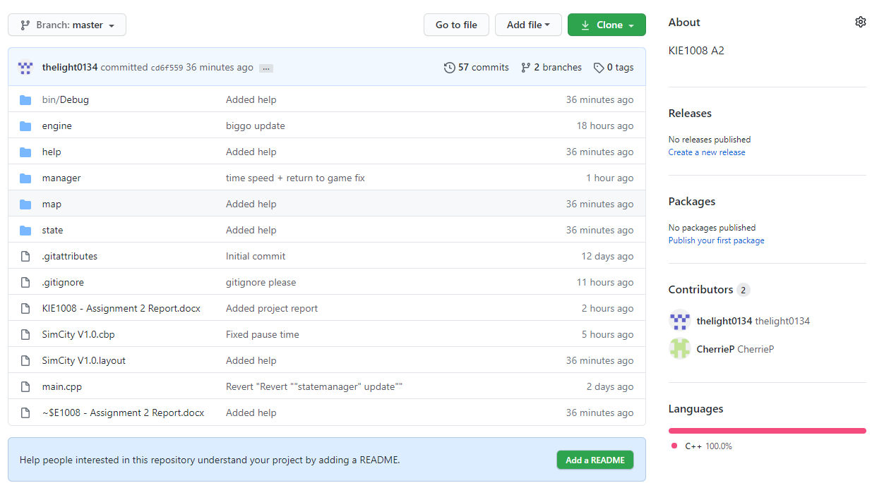

**Managers**

Managers is a set of class that manages the essential core of the program. From controlling what appear in console to getting user input.

* IO Manager

This class manage the input from user and manage the output on console output. This class consist of

1. File class - Load .txt file and store as vector of string.
2. getInput() - Capture user keystroke when the any key is pressed.
3. recursor(x,y) - Reposition the cursor location on console.
4. textColor(FG,BG) - Change the color of text on console.

- Map Manager

This class manage the game map file. The .txt file will be created when new map is generated. The .txt file will be updated when the game is saved. This class also store Day Passed an

* State Manager

This class manages the state of the program. Managing the cycle of draw, handle input and update.

* Time Manager

This class manage the game time. Calculating the second passed when new map is created or when the map loaded.

**States**

The state class is pure virtual class which inherited to gamestate, helpstate and menustate. All of these states will cycle through draw, handle event and update substate. All design of these state will be explained in design part of this report.

**Menu Design**

The option is numerated starting from 0 to 2.

* Initiation
* Clear the screen
* Active menu state
* Draw
* Print the menu
* Print the arrow according to selected option
* Handle Event
* Pressing UP will move up the option
* Pressing DOWN will move down the option
* Pressing ENTER will proceed with selected option
* Update
* Limit option between 0 and 2

**Help Design**